HDOC Day -17
Algorithm
- Start the program.
- Declare the required variables and functions.
- Display a menu with four options:
  - Generate the largest possible number.
  - Generate the smallest possible number.
  - Swap the first and last digits.
  - Check whether the number is a palindrome.
- Read the choice entered by the user.
- Use switch-case to select the required operation.
- For choice 1, call the largest() function, read the positive integer, arrange its digits in descending order, and display the largest possible number.
- For choice 2, call the smallest() function, read the positive integer, arrange its digits in ascending order, and display the smallest possible number.
- For choice 3, call the swapDigits() function, read the positive integer, exchange its first and last digits, and display the new number.
- For choice 4, call the palindrome() function, reverse the number and compare it with the original number. Display whether it is a palindrome or not.
- If the user enters an invalid choice, display "Invalid choice".
- Stop the program.

C-CODE:
#include <stdio.h>

void largest()
{
int n, a[20], i, j, temp, count = 0;

printf("Enter positive integer: ");
scanf("%d", &n);

while(n > 0)
{
a[count] = n % 10;
n = n / 10;
count++;
}

for(i = 0; i < count - 1; i++)
{
for(j = i + 1; j < count; j++)
{
if(a[i] < a[j])
{
temp = a[i];
a[i] = a[j];
a[j] = temp;
}
}
}

printf("Largest possible number = ");
for(i = 0; i < count; i++)
printf("%d", a[i]);
}

void smallest()
{
int n, a[20], i, j, temp, count = 0;

printf("Enter positive integer: ");
scanf("%d", &n);

while(n > 0)
{
a[count] = n % 10;
n = n / 10;
count++;
}

for(i = 0; i < count - 1; i++)
{
for(j = i + 1; j < count; j++)
{
if(a[i] > a[j])
{
temp = a[i];
a[i] = a[j];
a[j] = temp;
}
}
}

printf("Smallest possible number = ");
for(i = 0; i < count; i++)
printf("%d", a[i]);
}

void swapDigits()
{
int n, first, last, p = 1, temp, result;

printf("Enter positive integer: ");
scanf("%d", &n);

temp = n;

while(temp >= 10)
{
temp = temp / 10;
p = p * 10;
}

first = n / p;
last = n % 10;

result = n - first * p - last;
result = result + last * p + first;

printf("After swapping first and last digits = %d", result);
}

void palindrome()
{
int n, original, reverse = 0, digit;

printf("Enter positive integer: ");
scanf("%d", &n);

original = n;

while(n > 0)
{
digit = n % 10;
reverse = reverse * 10 + digit;
n = n / 10;
}

if(original == reverse)
printf("It is a palindrome number");
else
printf("It is not a palindrome number");
}

int main()
{
int choice;

printf("MENU\n");
printf("1. Generate largest possible number\n");
printf("2. Generate smallest possible number\n");
printf("3. Swap first and last digits\n");
printf("4. Check palindrome number\n");

printf("Enter your choice: ");
scanf("%d", &choice);

switch(choice)
{
case 1:
largest();
break;

case 2:
smallest();
break;

case 3:
swapDigits();
break;

case 4:
palindrome();
break;

default:
printf("Invalid choice");
}

return 0;
}
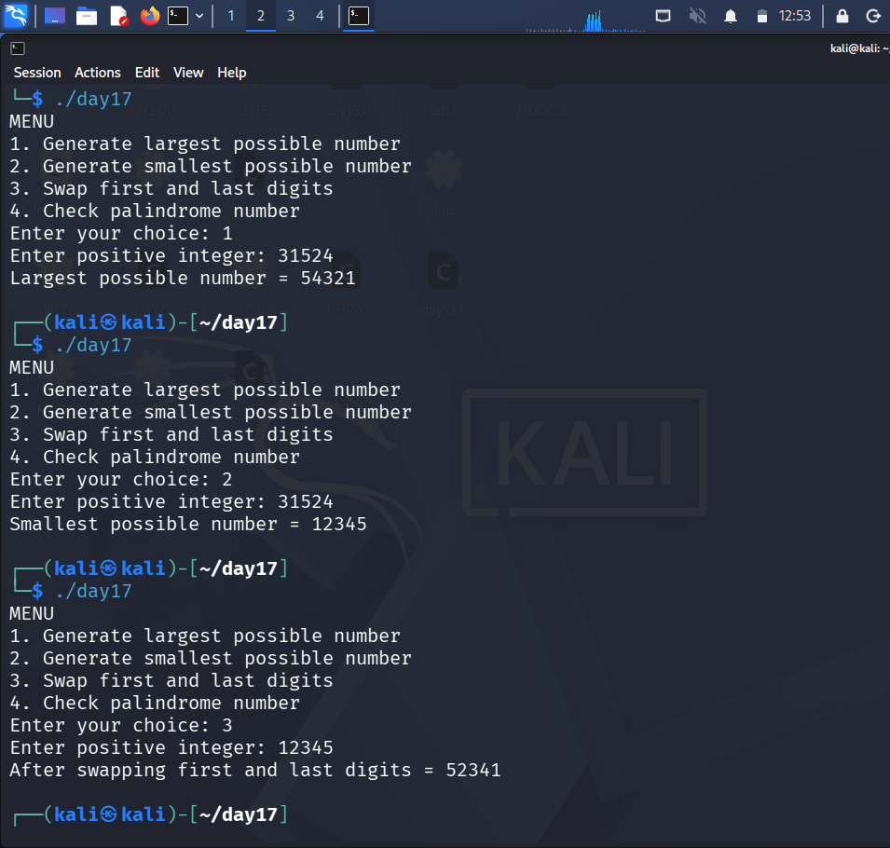
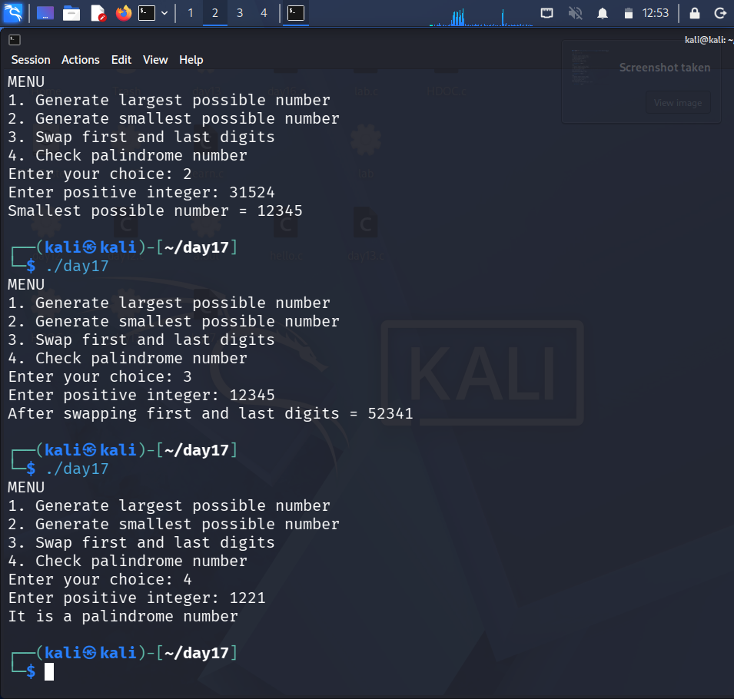
Test Case | Choice | Input | Expected Output | Actual output | Result
1 | 1 | 31524 | Largest possible number = 54321 | Largest possible number = 54321 | pass
2 | 2 | 31524 | Smallest possible number = 12345 | Smallest possible number = 12345 | pass
3 | 3 | 12345 | After swapping first and last digits = 52341 | After swapping first and last digits = 52341 | pass
4 | 4 | 1221 | It is a palindrome number | It is a palindrome number | pass

